UNIVERSITY OF INFORMATION TECHNOLOGY  COMPUTER ENGINEERING DEPARTMENT | FINAL EXAMINATION I (2019-2020)  COURSE: DEGITAL LOGIC DESIGN  Time duration: 60 minutes  (Paper materials are not allowed)  (OEP Students do the test by English,  Regular Students do the test by Vietnamese)  (Students need only do PART 1,  PART 2 has been done on class)
PART 1: PAPER TEST (3 points)

Question 1: (1.5 points)
- What is the multiple cycle design? Describe the disadvantages and advantages of multiple cycle design?
- What is the pipelined functional unit design? How does the pipelined functional unit design improve the performance compared with the non-pipelined functional unit design?

Question 2: (1.5 points)
Given the datapath pipelined design and its ASM for Square Root Approximation (SRA) calculation as below:
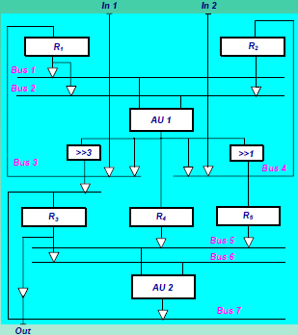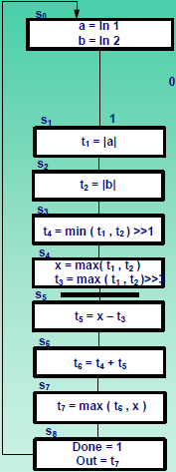
Where, R1 = [a, t1], R2 = [b, t2], R3 = [t3, t5, t6, t7], R4 = [x], R5 = [t4]
AU1 = [abs/min/max], AU2 = [+/-/max]
- Explain benefits of the datapath pipelined design?
- If there are 100 pairs of inputs (in1, in2), how many cycles are needed to calculate the SRA for these 100 pairs of inputs with above datapath pipelined design?

PART 2: COMPUTER TEST

Question 3 (3 points)
Design RTL circuit for Square Root Approximation (SRA) using functional-unit sharing. Two shared functional-unit groups, which are (abs/max) and (abs/min/+/-) are used to design.

Question 4 (4 points)
Design RTL circuit for Square Root Approximation (SRA) using datapath with pipelined functional unit.

This examination’s learning outcomes (LO) (matching to subject syllabus’s LO)
Question | LO | Description
1 | G4 | Ability to comprehend professional materials
2 | G2 | Ability to know analyze the cost and latency of the circuits, use ASM and FSMD models in the design process
3 | G1 | Ability to analyze finite state machine circuits, data paths, and control units.
4 | G2 | Ability to to optimize the circuits use ASM and FSMD models in the design process

Approved by Head of Subject Designed by

